**Course _______Specialist______ Year __12_____**

Student name: ________________ Teacher name: ________________

Date: Fri week 5

**Task type: Response**

**Time allowed for this task: _____45______ mins**

**Number of questions: _____6______**

**Materials required:** No cals

Standard items: Pens (blue/black preferred), pencils (including coloured), sharpener, correction fluid/tape, eraser, ruler, highlighters

Special items: Drawing instruments, templates, , and up to three calculators approved for use in the WACE examinations

**NO NOTES ALLOWED**

**Marks available: __39____ marks**

**Task weighting: _12___%**

**Formula sheet provided: Yes**

**Note: All part questions worth more than 2 marks require working to obtain full marks.**

**Q1 (4.1.2) (3, 3 & 3 = 9 marks)**

Determine the following integrals showing full working.

1. 

|  |
| --- |
| **Solution** |
|  |
| **Specific behaviours** |
| 🗸 uses change of variable and its derivative  🗸 derives new integral  🗸 obtains result with a constant |

1. 

|  |
| --- |
| **Solution** |
|  |
| **Specific behaviours** |
| 🗸 uses change of variable and its derivative  🗸 derives new integral  🗸 obtains result in terms of x |

1. 

|  |
| --- |
| **Solution** |
| Alternative |
| **Specific behaviours** |
| 🗸 uses change of variable and its derivative  🗸 derives new integral  🗸 obtains result in terms of x |

**Q2 (4.1.1 -4.1.3) (3, 3 & 3 = 9 marks)**

Determine the following definite integrals showing full working.

1. 

|  |
| --- |
| **Solution** |
|  |
| **Specific behaviours** |
| 🗸 uses double angle formula for cosine  🗸 obtains antiderivative  🗸 obtains exact value |

1. 

|  |
| --- |
| **Solution** |
|  |
| **Specific behaviours** |
| 🗸 uses trig identity  🗸 obtains antiderivative  🗸 subs limits to show value |

1. 

|  |
| --- |
| **Solution** |
|  |
| **Specific behaviours** |
| 🗸 uses trig identity  🗸 obtains antiderivative  🗸 subs limits to show exact value |

**Q3 (4 marks)**

Determine the following integral showing full working.



|  |
| --- |
| **Solution** |
| (Note: if only two terms used- max of 2 out of 4 marks) |
| **Specific behaviours** |
| 🗸 uses partial fractions  🗸 sets up equations to solve for constants  🗸 solves all 3 constants  🗸 anti differentiates all terms (no need to add constant) |

**Q4 (4.1.5-4.1.6) (5 marks)**

Consider a cylindrical drill of width 2 cm that carves a cavity inside a solid sphere of radius 5 cm as shown below. Determine the volume of the sphere remaining.(Simplify)

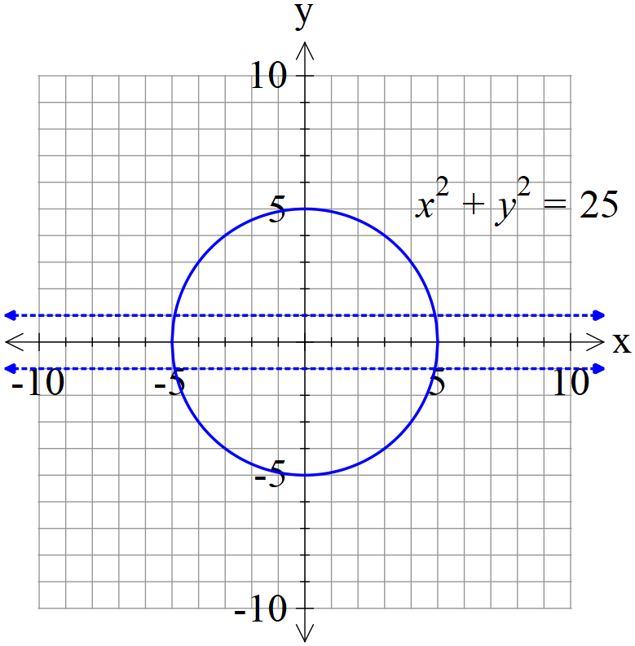

|  |
| --- |
| **Solution** |
| (Note- max 2 out of 5 if they have removed all of sphere between y=-1 and y=1) |
| **Specific behaviours** |
| 🗸 solves for when y=1  🗸 uses solid of revolutions integral  🗸 sets up correct integral for volume remaining  🗸 anti-differentiates  🗸simplifies to one term/surd |

**Q5 (4.2.4) (4 marks)**

Determine the solution to the following differential equation  given that (1,1) is a known point.(No need to simplify)

|  |
| --- |
| **Solution** |
|  |
| **Specific behaviours** |
| 🗸 separates variables under integration  🗸 integrates y terms  🗸 integrates x terms  🗸 solves for constant (unsimplified) |

**Q6 (4.2.6) (1, 5 & 2 = 8 marks)**

Consider the differential equation  with  positive constants.

1. Determine the limiting value for  as 

|  |
| --- |
| **Solution** |
|  |
| **Specific behaviours** |
| 🗸 states value for N |

1. Show how to derive using integration and partial fractions that the general solution is 

|  |
| --- |
| **Solution** |
|  |
| **Specific behaviours** |
| 🗸 separates variables  🗸 sets up partial fractions for N  🗸 shows how to find constants for partial fractions  🗸 states that a-bN>0  🗸derives logistical formula |

1. Consider  with an initial value of . Determine  when t=50.

(No need to simplify)

|  |
| --- |
| **Solution** |
|  |
| **Specific behaviours** |
| 🗸 solves for constant  🗸 expresses exact value at t=50 |